Gathering gently

On Good Friday we are invited to enter the story of Jesus’ betrayal, arrest, trial, crucifixion and burial. It’s hard and it’s horrifying to imagine the suffering of the one we love so much. It may fill us with grief, and connect with the grief we carry because of others we have loved and lost.
Be gentle with yourselves; approach boldly, and with care. If you need to lean on someone, make sure you do, as we walk together on this pilgrim path.

Preparation: You may choose to gather a bowl of rosemary sprigs for the Prayers of the People. Find some readers and maybe symbols to bring forward at the appropriate time.

Call to worship & Lighting the Candle

Light the candle - Christ is with us.

Acknowledging

As we gather, we acknowledge the First Peoples of this land, the traditional custodians, and we pay our respect to elders. We commit ourselves to entering the hard stories of our past, and to working for justice and peace for all people.

Singing - Here hangs a man discarded TiS 356
OR: Marty Haugen’s song - “O God why are you silent” to the tune PASSION CHORALE - TiS 339
https://miahimnareto.wordpress.com/2008/07/01/o-god-why-are-you-silent/

Prayer 

Voice 1:
A reading from Psalm 22:1 -2
My God, my God, why have you forsaken me? Why are you so far from helping me, from the words of my groaning?
O my God, I cry by day, but you do not answer; and by night, but find no rest.

Voice 2:
An interpretation:
Hear my lament, my God, my God, my God.
Why have you left me bereft, without you?
Right now, I feel ditched, deserted and discarded and there’s so - much - space between us.
Can you even hear me?
I’ve been calling through the dark
and crying in the light
and I’m getting nothing back from you.
Nothing. I’m spent, exhausted, drained ...

Voice 1:
A reading from Psalm 22:3-5
Yet you are holy, enthroned on the praises of Israel.
In you our ancestors trusted; they trusted, and you delivered them.
To you they cried, and were saved; in you they trusted, and were not put to shame.

Voice 2:
An interpretation:
Still, I remember, you are beyond all that I know, you are mystery and majesty.
All the songs and psalms and sighs of your people long gone, echo into my ears
from the heavenly places,
and burrow into my soul with assurance.
They cried, you heard, they were saved.
Let it be so.

So we pray:
Hold our hands, God of promise
as we walk into this night space,
this dark place, this hard time.

We remember with gratitude all those times
when you have held us in the darkness:
the darkness of fear, doubt and grief.
You held us like a mother
cradling a frightened child,
soothing, rocking, keening us into calm.
(silence)

Hold our hands, God of promise
as we walk into this night space,
this dark place, this hard time.

We remember with gratitude all those times
when you have sent us to sit beside others
in their dark and troubled times.
When our hands were your hands,
when our hearts held their pain,
when our tears fell together, as you wept with us.
(silence)

Hold our hands, God of promise
as we walk into this night space,
this dark place, this hard time.

We confess the times:
when we refused to let you sit with us
in the darkness of our despair,
when we refused to surrender
to your outstretched arms of love ,
when we turned our backs
on the cries of pain from others.

Hold our hands, God of promise
and forgive us for turning away,
forgive us for shutting you out,
forgive us for failing to share
the compassion of your forgiving embrace.
(silence)

Siblings in Christ,
know this, in your hearts,
and live as if you believe it:
that you are loved by the God
who surrendered all to bring you to life.
You are forgiven,
Thanks be to God, Amen.

Listening

You may want to break the reading into sections, you can sing ‘Jesus, remember me,’ (TiS 730) between each one. You could also add symbols being brought forward at the appropriate time eg: A robe, a crown, a cross, a cloth, etc…

Listen, listen, listen:
Read: Isaiah 53: 1 - 12,
John 18: 37 – 19: 6, 13 - 30

For these words of faith and for Jesus the Word
Thanks be to God.

Reflecting - Rev. Ian Brown
‘A world of brokenness’

The world is in the thrall of dictators, thugs and insanity! Everything is being upended, values rewritten and greed becomes the ultimate arbiter. The story and its truth that we gather around today addresses the same human dynamic and shows how Jesus dealt with it. There’s a cross and unjust suffering, there’s pain and deceit, abandonment by friends and undercurrents full of mystery. A world of brokenness!

It’s tough reading! We’d prefer some relief, the tender shepherd of Psalm 23 rather than the abandonment of Psalm 22! Suffering, betrayal, lies, unjust trial, torture and death are hard to confront even in a familiar story.

Isaiah wrote, “He was oppressed, and he was afflicted, … By a perversion of justice he was taken away… For he was cut off from the land of the living.” The Romans had a particularly brutal means for cutting off. And ever since Jesus, the imagery of Isaiah’s poetry has been associated with the cross. Isaiah’s writing was to Israel, the ‘suffering servant’ seen as an embodiment of the nation. Since early Christian writing, Isaiah’s poetry has been used to help us understand Jesus, who characterizes his people and lives out God’s mission that’s expressed here.

There’s a profound and difficult relationship of meaning in these texts. “he was wounded for our transgressions, crushed for our iniquities; upon him was the punishment that made us whole, and by his bruises we are healed.” It’s rich with poetic meaning, but... how does the suffering of one help another?

It’s a dilemma; how can God be seen to deal with humanity and the problems of evil and death by engaging with more of the same? In the broad sweep of John’s gospel Jesus does his major work on the cross. Half the gospel; chapters 12 – 21 are the story of Holy Week, the cross and resurrection.

The cross was a brutal instrument of Roman law and order. But the sign of Roman domination has been remade by Jesus into a sign of transformation. Repulsion was a natural reaction to the cross. This central Christian symbol, the cross, is a scandal. It’s a reminder of the use of violence. An ugly thing and yet! This was how Jesus was ‘lifted up’ – glorified, in John’s telling.

The sign of the cross was also the sign of Jesus' response to power. He responded with powerlessness and self-giving that led to transcending death. Jesus takes on brutality by submitting to it. The cross that we sing about and meet around reminds us that God stands with those who are victims of brutality. The readings take us back into the territory of our troubled humanity and what role our faith might play in it. How can we respond to tragedy and suffering today? The pattern we see in Jesus’ cross is one of confronting the worst without weapons and working through it.

It’s profound that at the very centre of our faith is the story of suffering, death and resurrection. We must face the darkness, the endings, the reality in front of us. There can be no healing until suffering and death have been faced.

This story is all scandal; brutal and unjust, but Jesus deals with it, he stays engaged, experiences the whole mess and identifies with the worst of our pain. Perhaps we’re invited, through this story, to be people prepared to face our pains before God, and be prepared to stand alongside others in their times of need. The cross then might best be seen as the sign of God with us. With us in the worst of life, giving a promise of the transformation of death into new life. The cross is a sign in which Jesus makes God known, present and active in transformation. This is what Jesus does in the face of a world of brokenness.

Are we open to that?

Singing - Were you there - TiS 345 (omit verse 6)
OR: O sacred head, sore wounded TiS 339

Prayers for World & Community

If you have a basket of rosemary sprigs, invite people to come forward during the prayer, when they are ready, and take one or two to keep in their pocket, or to place at the foot of the cross, or to give to someone, as a reminder of the presence of God in our darkest times.

They may also add a phrase of prayer, with people responding: Jesus, remember them.

God who knows suffering and death,
you are here, in the suffering of our world
present in the places of death,
in the hard spaces, in the pain.

(The following are suggestions for your prayer, you may like to leave a space for people to add something that is on their hearts.)

We pray for those who are filled with grief,
Jesus, remember them

We pray for women who have been abused
Jesus, remember them

We pray for people who have been accused
Jesus, remember them

We pray for creatures struggling to survive
Jesus, remember them

We pray for the dying, struggling to breathe
Jesus, remember them

We pray for people overwhelmed with pain
Jesus, remember them

We pray for children who are alone
Jesus, remember them

(Quiet space for people to add their prayers)
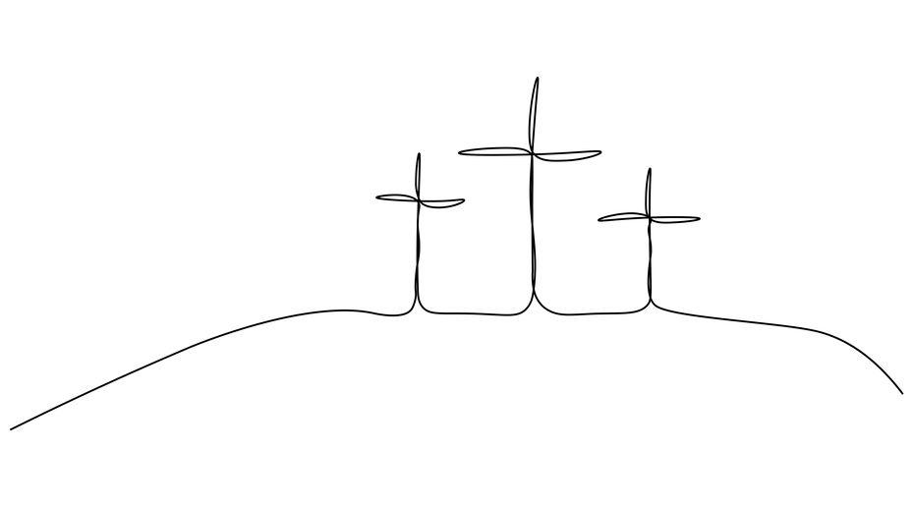

We pray for ourselves, and all of humanity
Jesus, remember us
as we pray the prayer you taught us:

The Lord’s Prayer
Our Father in heaven, hallowed be your name,
your kingdom come,
your will be done, on earth as in heaven.
Give us today our daily bread.
Forgive us our sins,
as we forgive those who sin against us.
Save us from the time of trial
and deliver us from evil.
For the kingdom, the power, and the glory
are yours, now and forever. Amen.

Singing - When I survey the wondrous cross TiS 342
OR: My song is love unknown TiS 341

The candle is extinguished. This liturgy does not conclude with a word of mission or a blessing, as the worship is held open until Easter morning.


Reflection: Rev. Ian Brown
Wattlebird Ministry Team - Warragul

Liturgy & Editor: Rev. Jennie Gordon
St John’s UCA, Cowes.
revjenniegordon@gmail.com

